{Lesson: Community Safety video title: community_safety_teen}
Script | On Slide Text | Animation Notes
[>>1]Molo! Kwakuhle ukukubona kwakhona! This course is all about keeping your teen safe and healthy and today we are learning about community safety.  One way to keep your teen safe is to create a safety map with them. Together you can identify the safe and unsafe places in your community.  Here are three steps to help you create your map with your teen:  [>>2]Draw[pause],[>>3] Decide[pause], and  [>>4]Discuss.  Masifunde ngakumbi kunye!  [<<all] | [1]Community Safety  [2]DRAW  [3]DECIDE  [4]DISCUSS | {cues for on-screen text animation: >> means enter Left to right  << means exit right to left. Please time with speech as indicated.}
[>>1]The first step is to DRAW.  With your teen, draw a map of your community. Include all the main places you and your teen go like [2]your house, school, streets, shops, and other places your teen visits.  [<<all] | [1]DRAW  [1]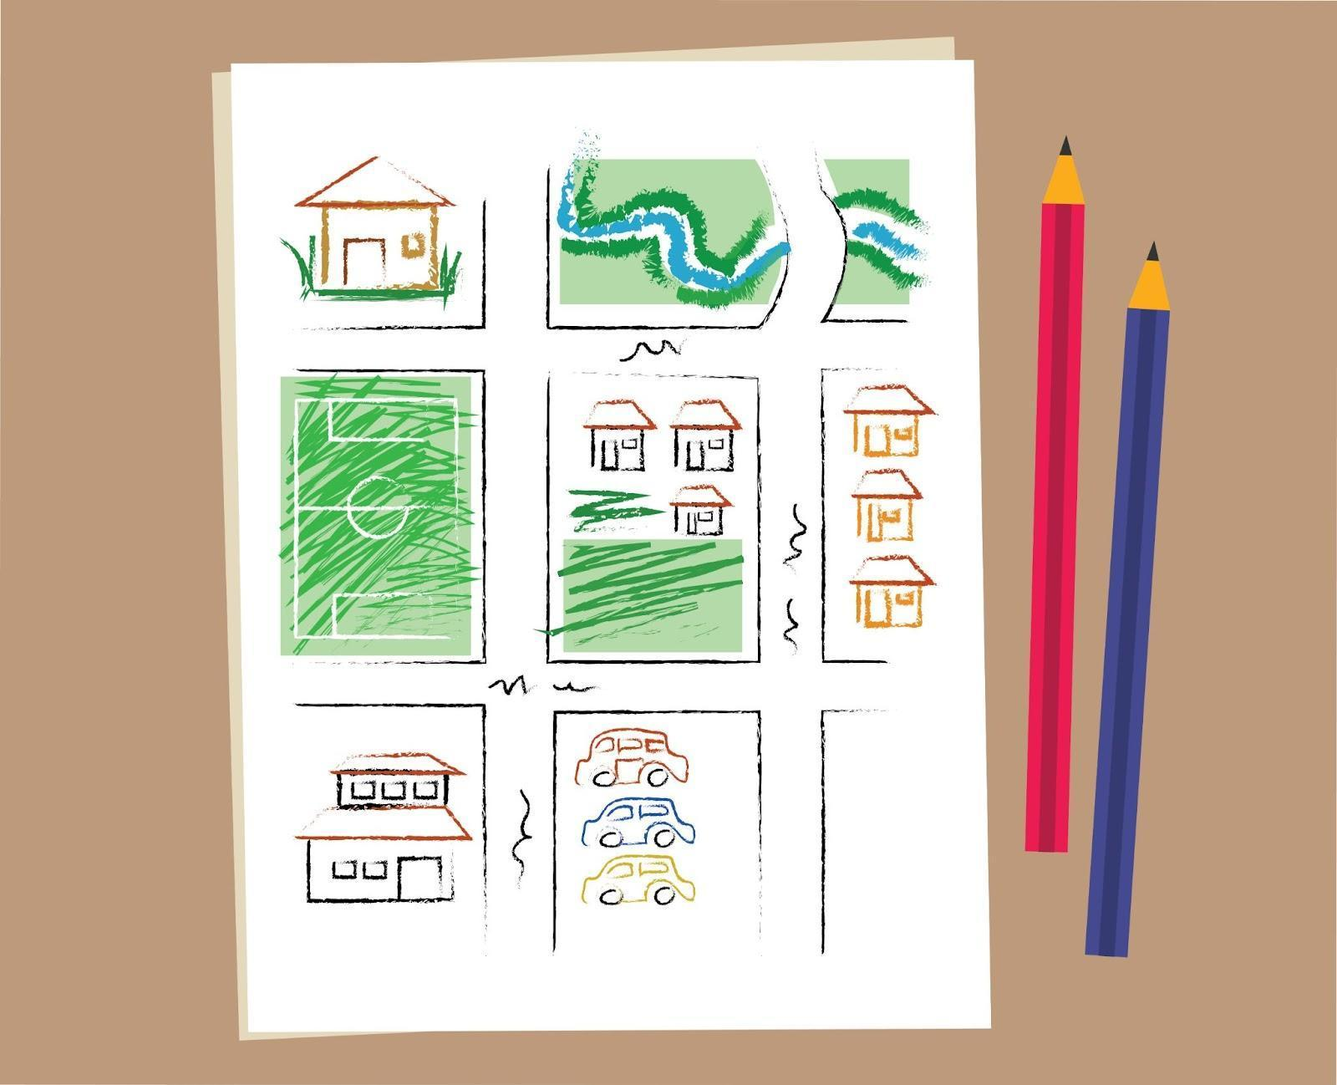 | {Begin with blank sheet (add white overlay over the drawing to show blank sheet of paper). At [2] the white shape fades out and reveals the drawing in the community_safety_draw. See reference video for example. }
[>>1]The next step is to DECIDE.  Talk with your teen about the places on your map and decide whether they are safe or not. Remember to let your teen share their thoughts and listen to them. They might know more than you think they do about where it is safe or unsafe! When you have decided which places are safe for your teen,[>>2] draw a circle around them. Then, cross off any places that aren’t safe for teenagers. | [1]DECIDE | {Begin with community_safety_draw on screen. Overlay community_safety_decide on [2]}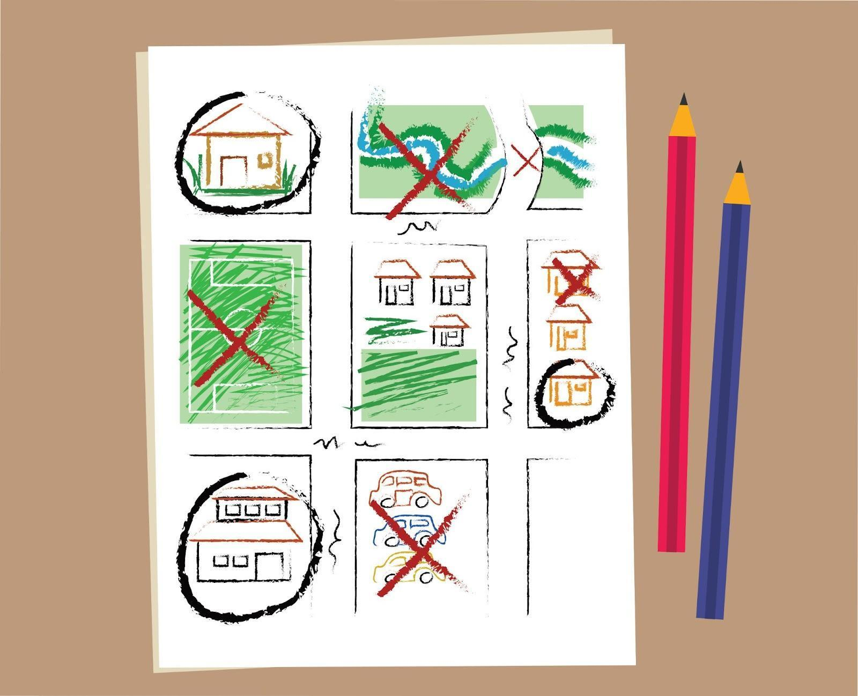
[>>1]The final step is to DISCUSS.  Ngamanye amaxesha, sizifumana sisengxakini. Discuss where you and your teen can get support in a crisis. This may be home, school, a police station, or a clinic. [>>2] Mark these places clearly with a star on your map.  [<<all] | [1]DISCUSS   | {Begin with community_safety_decide. Overlay community_safety_discuss on [2]}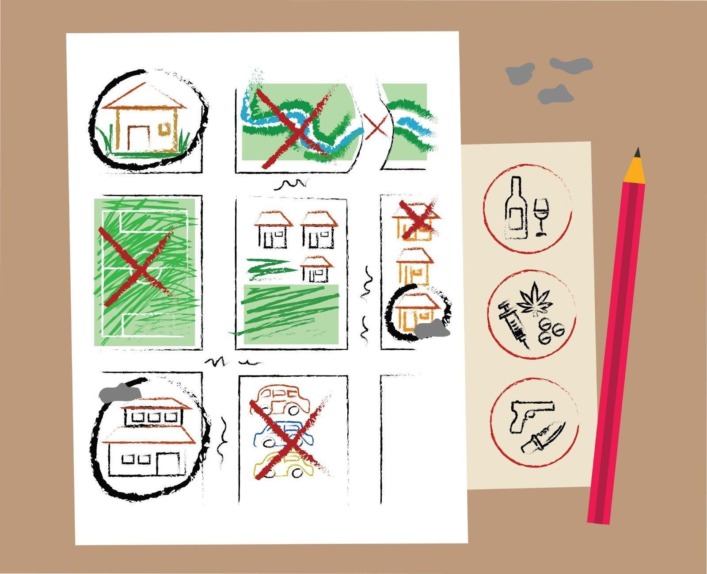
[>>1]Remember, the three tips to create a community safety map are  [>>2]draw, [pause][>>3] decide[pause] [>>4]and discuss.  Talking about safety with your teen is a small way to make a big difference. Remind them that they can tell you about anything unsafe that happens without you getting angry. This will help you build trust with your teen.  [<<1-4, >>5]  Your home activity is to create a community safety map with your teen. Ingaba unalo ixesha lokuyenza namhlanje? | [1]Community Safety  [2]DRAW  [3]DECIDE  [4]DISCUSS  [5]Home Activity:  [5]Create a community safety map with your teen

{Lesson: Respond to Crises video title: crises_teen}
Script | On Slide Text | Animation Notes
[>>1]Welcome back! Today we are learning about how to respond to your teen in a crisis.  When our teens share something that is very hard or upsetting to them, we need to remember to stay calm, listen, and be open so that they feel supported.  Here are some things you can do to support your teen when they share something difficult with you:  [>>2]breathe, [pause][>>3]listen,[pause][>>4] respond [pause][>>5] and comfort.  Let’s learn more about these steps together. [<<all] | [1]Respond to Crises  [2]BREATHE  [3]LISTEN  [4]RESPOND  [5]COMFORT
[>>1] The first step is to breathe. [>>2]Stay calm. Ask yourself, “What does my teen need right now?”  While at first we might feel concerned, anxious or even angry, it’s important to remain calm and be there for your teen in the moment.  [<<1,2]  [>>3]] Next, listen. [>>4]Ask your teen what is going on and let them share with you what they need.. Notice what they are feeling and tell them what you notice so they feel heard.Remember to tell your teen you are there for them and love them.  [<<3,4]  [>>5]The third step is to respond. [>>6]What might help the situation? You might need to help your teen talk about their feelings or redirect their focus. Or you might need to discuss immediate actions to help them. You can give consequences later if needed.  [<<5,6]  [>>7]Finally, comfort your teen.[>>8] It can be hard to see your teen feeling upset or confused, but there is a lot you can do to support them. They need you to accept them and provide comfort when in difficult situations.  [<<7,8] | [1]BREATHE  [2]Remain calm.  [3]LISTEN  [4]Ask your teen what is going on.  [5]RESPOND  [6]What can help your teen right now?  [7]COMFORT  [8]Give your teen comfort.
[>>1]Remember, you can always type HELP to ParentText to receive a list of contacts in your community for crisis support. They may be able to help. [<<1] | UNCEDO | {[1]Overlay image help_template}
[>>1]It can be difficult to see your teen feeling upset or confused, but remember that there’s plenty you can do to support them during a difficult time. Uyiphethe lento, ungumzali omhle kakhulu!  [>>2-5]  Follow these steps whenever your teen shares something difficult. Supporting your teen through a crisis will also teach them how to support others in difficult times.  [<<all] | [1]Respond to Crises  [2]BREATHE  [3]LISTEN  [4]RESPOND  [5]COMFORT
[>>1]For your home activity, [>>2] Find a calm time to talk with your teen about possible crises that may happen.[>>3] Discuss what to do if they happen.[>>4] Revisit the Mapping Activity to identify other sources of support in the community. [>>5] And thank your teen for taking the time to chat about this.  Do you have time to do this today? | [1]Home Activity:  [2] Talk with your teen about possible crises.  [3] Discuss what to do if they happen.  [4] Revisit the community safety map and identify other sources of support in the community.  [5] Thank your teen. | {Animate sentences to script either as bullets or in paragraph form. Overlay community_safety_discuss on [3]  If there is not space to have [2]-[5] on screen together, bring in [2] and [3] as indicated, then exit before bringing in [4] and [5].}  

{lesson: Prevent Sexual Violence video title:sex_violence_teen}
Script | On Slide Text | Animation Notes
[>>1]Welcome back! It is great to see you again.  In today’s lesson we are learning about preventing sexual violence. It can be hard to think about your teen being in a dangerous situation but understanding their reality and potential risks for them helps us to keep them safe.  We can help our teens know how to use their thoughts and voices in dangerous situations to stay safe. It makes a big difference!  In a dangerous situation, we may not know what to do and freeze or respond in an angry way – this is normal. These tools can help keep you and your teen safe: [>>2]know it,[>>3]see it, [>>4] and say it.  Let’s explore these together.[<<all] | [1]Prevent Sexual Violence  [2]KNOW IT  [3]SEE IT  [4]SAY IT
[>>1] First, know it. Know the difference between healthy and unhealthy relationships. [>>2}Remember, if you are attacked, it is never your fault. You are allowed to say and do what is needed to stay safe and get away – do not worry about what others may think. You are strong and powerful and deserve defending.[<<1,2]  [>>3] Next, see it. [>>4}When someone makes you (or someone else) feel uncomfortable with what they say or do, that is never okay! We all have the right to feel safe, especially at home. Follow your intuition. When you feel attacked with words or actions, your goal is to get away.  [<<3,4]  [>>5] Third, say it. Your voice can stop many attacks. [>>6] Be clear, confident, and direct. [>>7]Speak using your voice, body language, and eye contact. If you don't feel safe, you can do whatever it takes to get away.  [<<6,7]  Using your voice can look different in different situations. You could shout [>>8]"No!", [>>9]]call for help,[>>10] act strangely to confuse the attacker,[>>11] or negotiate.  [<<8-11]  [>>12]Here are some things you might say or shout to avoid a tough situation:  “I will call the police if you touch me again.”  “Do not touch my bum!”  “No lift for me, thanks! Last time I got a lift, I threw up!”  “I will give you my phone if you let me go.”  [<<12]  [>>13]Think about what you would do in the examples from this lesson. There is no wrong answer! | [1]KNOW IT  [2]Know that it is not your fault.  [3]SEE IT  [4]Recognize when you are unsafe.  [5]SAY IT  [6]Be clear,, confident and direct.  [7] Use your voice, body language and eye contact.  [8] “NO!”  [9] Call for help  [10]Act strangely  [11] Negotiate  [13] What would you do? | {[8] add a megaphone icon overlaid inline with the text ( after text) to emphasise shouting}  {[12] add emoji or simple line graphic icons/images to illustrate the sentence. Forexample, a blue police light or police car for sentence 1 which talks about the police}
[1]If you do get hurt by someone, remember it is never your fault. [2]Ask someone you trust for help, and make sure your teen knows they can tell you anything so you can find a solution together.  [<<all] | [1]It is not your fault.  [2]Ask a trusted adult for help | {keep [5] up}
[>>1]Remember, you can always type help to ParentText to receive a list of contacts in your community for crisis support. They may be able to help.[<<1] | UNCEDO | {[1]Overlay image help_template}
[>>1,2]Your home activity is to help your teen be prepared by repeating this lesson together. To repeat this lesson type “PREVENT.” Can you do it today? | [1]Home Activity: [2]Type “PREVENT” and repeat this lesson with your teen.

{Lesson:Knowing Basics of Online Safety video title: online_safety_teen}
Script | On Slide Text | Animation Notes
Molo kwakhona! Today’s lesson is about how to keep your teen safe online.  Teens are spending a lot of time online. Ukuqhagamshelana kubanceda bahlale bekhuthazekile kwaye bafunda lukhulu, kodwa ikhona nayo imingcipheko kunye neengozi. Keeping your teen safe online is an important step to help them be part of the digital world.  Xa kufikwa kukhuseleko lwe intanethi, kukho ingcebiso ezine ekufuneka uzigcine engqondweni:  [>>2]learn,  [>>3]protect,  [>>4]build habits,  [>>5]and build trust.  There is so much to share that we will cover online safety over two lessons.  [<<4,5]Today, we are reviewing the tips [pause] learn [pause] and protect.  The next lesson will cover [pause] build habits [pause] and build trust.  Masiqaliseni.  [<<all] | [1]Knowing Basics of Online Safety  [2]LEARN  [3]PROTECT  [4]BUILD HABITS  [5]BUILD TRUST | {Please refer to example video for additions of icons. }
[>>1]First, learn the dangers of being online:  [>>2]CONTENT: Your teen might come across harmful content or content you think is inappropriate for them, such as violence, aggressive language, or pornography. [<<2]  [>>3]CONTACT: Adults might pretend to be teens and ask for sexual pictures or to meet with your teen through an online platform.[<<3]  [>>4]CONDUCT: Sometimes, teens or strangers can say or do hurtful things online.[<<4,5] | [1]LEARN:  - [2]Content  - [3]Contact  - [4]Conduct
[>>1]Next, protect. Keep your teen safe online.  [>>2]Talk to your teen about which apps and websites are safe and which are not. Make sure to have a discussion about why! [<<2]  [>>3]Help your teen learn how to make strong passwords to protect their devices. [<<3]  [>>4]Teach your teen that they should keep personal information private, including photos or videos of themselves. What goes online stays online![<<1,4] | [1]PROTECT  - [2]Talk to your teen about safe apps  - [3]Help your teen learn about strong passwords  - [4]Tell your teen what should be kept private
[1]In the next session, we’ll continue learning about online safety. Today, your[<<1>>2]home activity is to ask your teen what they do to stay safe online. Ungafumanisa ukuba bahlale becinga ngokhuseleko kwi intanethi. Praise your teen for any efforts they make. Can you talk with your teen today? | [1]Know Basics of Online Safety  Funda ✅  Khusela  Yakha Imikhwa  Yakha Ithemba  [2]Home Activity:  Ask your teen what they do to stay safe online

{Lesson: Build Habits and Trust Online video title: habits_online_teen}
Script | On Slide Text | Animation Notes
[>>1]Welcome back to ParentText ! This lesson continues our learning about keeping our teenren safe online.  Keeping your teen safe online is an important step to help them be part of the digital world.  [>>2,3,4,5]You already learned ways to protect your teen online with [<<2]learn and [<<3]protect in the previous lesson.  Today, we are learning how to build habits and build trust.  Are you ready to begin?[<<all] | [1]Build Habits and Trust Online  [2]LEARN  [3]PROTECT  [4]BUILD HABITS  [5]BUILD TRUST | {Please refer to example video for additions of icons. }
[>>1]The next step is to build habits. Ukumisela imikhwa yokhuseleko kwi intanethi ekhayeni.  [>>2]Plan phone-free times in your house, like during meals, homework, or in bed.  Set limits on the amount of time your teen spends online.  [3]Create rules with your teen about who they can chat with online. It is safest to only chat with people they already know. Bangaze babelane ngenkcukatha zabo kwi gumbi lokuncokola labucala okanye nabantu abangaziwayo.  [>>4]Before completing forms that ask for personal information, check that the web address begins with https://. Websites that begin with http:// may not be secure.[<<4]  [>>5]For older teens, you can help them create strong passwords for their accounts. Inombolo eziqinileyo zi:  [pause][6] long  [pause] [7]do not include obvious personal information like your name or birthday;  [pause][8] and include upper and lower case letters, numbers and symbols.[<<5-8]  [>>9]Tell your teen not to click on pop-ups that ask them to download or pay for anything. | [1]BUILD HABITS  [2]Set phone-free times in your house  [3]Create rules for who to talk to online  [4]Check web addresses  https://  http://  [5]Set Strong Passwords:  [6]Long  [7]Don’t include personal information  [8]DO include upper and lowercase letters, numbers, and symbols  [9] Be careful of pop-ups | {Animate password details to explain better. See reference Video}
[>>1]Finally, BUILD TRUST with your teen  [>>2]Together, look at the websites, social media, games, and apps they use.  [>>3]Ask questions - this helps you learn more about your teen's interests!  [>>4]If you come across anything worrying together, talk about it with your teen. [>>5]If you need support, type HELP after you complete today’s lesson or any time you need extra support.  [>>6]Tell your teen that they should tell an adult if they feel scared, unsafe or upset about something online.  Teach your teen that if a stranger offers gifts, like virtual coins, in exchange for photos and personal information, and tells them to keep it a secret, they should tell you. | [>>1]BUILD TRUST  [2]Look at websites, social media, games and apps that your teen uses, together  [3]Ask questions  [4]Talk about worrying things together  [6]Tell your teen if they feel scared or unsafe, they should tell an adult | {[5]Overlay image help_template}
[>>1]Just as you keep your teen safe in the real world, you also need to make sure they are safe in the digital world. Ngokulandela lamanyathelo ungabakhusela kwaye uqinisekise ukuba ixesha labo kwi intanethi likhuselekile ukwenzela baqhubeke nokuyisebenzisa ukuze bafunde. Wenza umsebenzi omhle kakhulu!  [<<1]  [>>2] Here’s something you can do with your teen today to start making sure they stay safe online:  [>>3]  First, have a conversation with your teen about how they can use the internet and devices in a safe way.  [>>4]  Okulandelayo, thetha malunga ngeziphi ii webhusayithi okanye ii apps ezinokungakhuseleki. Xoxani ukuba kutheni.  [>>5]  Finally, praise your teen for how good they are at using the web!  Can you and your teen complete this task today? | [1]Build Habits and Trust Online  [2]Home Activity  [3]Have a conversation with your teen about how they can use the internet and devices in a safe way.  [4]Talk about which sites or apps might be unsafe and why?  [5]Praise your teen for how good they are at using the web safely!

